A Holocaust Survivor’s Prayer

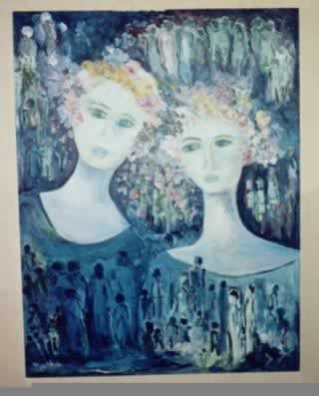
My Twin Sisters painting by Malka B.
My parents were originally from a small town near the larger city of Lodz, in Poland. They came to live in Paris right after their marriage in 1930, and I was born there in August of 1931. Ours was a large family.
A Survivor’s Prayer
By:
MalkaB
I have lived
dear G-d
in a world gone mad
and I have seen
evil
unleashed beyond reason or
understanding.
I was with them.
We drank from the same
bitter cup.
I hid with them
Feared with them,
Struggled with them
And when the killing was finally done
I had survived
while millions had died.
I do not know why
I have asked many questions
for which there are no answers
And I have even cursed
my life
thinking I could not
endure the pain.
But a flame
inside
refused to die.
I could not throw away
What had been ripped away
from so many.
In the end
I had to choose life.
I had to struggle to cross
the bridge between
the dead and the living.
I had to rebuild
what had been destroyed.
I had to deny death
Another victory.

