Follow the directions given for each section. Control/Click on every single link. Answer all questions thoroughly in a shared Google Doc with your group. Do not cut and paste. Rephrase the answers in your own words. This is a group classwork grade and must be uploaded to google classroom. Any person in the group NOT contributing will work alone.
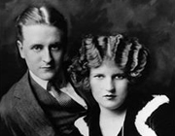
- F. Scott Fitzgerald
Skim the biography of F. Scott Fitzgerald. What intrigues you about Fitzgerald's life and writing? Note: Do not simply copy out the first sentence. Skim the entire biography and be sure you are thinking about this question.
- World War I
  - After the war ended, the economy skyrocketed, making it possible for people to spend more time and money on leisure activities. Review the website in this section. What are three major innovations that came out of the WWI experience?
  - After the War: What are the dominant postwar American attitudes and the major movements of the 1920's? Pay close attention to the attitudes of the "Lost Generation" and the "Prosperity & Consumerism" movement.
- 19th Amendment
What right did women gain from the passage of the 19th Amendment?
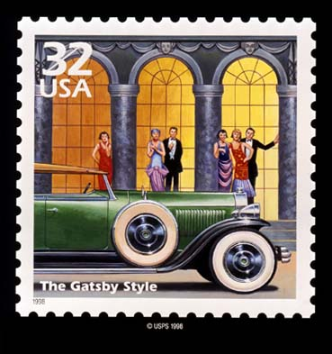
- The Roaring Twenties
List three major events that occurred in 1922 (the year in which the novel is set). Note: You will want to skim this list and look for events that would have been important in America.
- 18th Amendment
  - What exactly does the amendment abolish? What was the result?
  - 18th Amendment
  - Wikipedia: Eighteenth Amendment to the United States Constitution
- Prohibition
  - What is a Speakeasy? Based on information you have already collected from previous questions, why do you think Speakeasies popped up across the country?
  - Wikipedia: Speakeasy
  - Speakeasy photos
- Organized Crime and Arnold Rothstein
  - Arnold Rothstein on Biography.com: What are three elements of Rothstein's biography that interest you? Explain.
The Mob's Greatest Unsolved Hits: Arnold Rothstein: What is the most interesting thing you learned in this article that was not in the previous article? Explain.
  - Did your impression of Rothstein change from one web page to the next? Explain.
- Flappers
  - Read the first five paragraphs of the article about "Flapper Jane." According to the author, what are the essential elements of being a true flapper?
  - After reading the article, look at the selected photos of Louise Brooks. Does she fit the "Flapper" profile as proposed by the author of "Flapper Jane"? Why or why not?
  - Read Dorothy Parker's poem "The Flapper." How does Ms. Parker feel about Flappers? Explain.
- Automobiles
  - Why were cars considered "the most important catalyst for social change in the 1920's"?
  - The Rise of Automobiles
  - Photos of 1920's era automobiles.
  - Gatsby Coachworks: Reproductions of 1920's era automobiles. The white and gold car is similar to what Jay Gatsby would have driven.
- Music
  - Listen to the music on the Spotify music player to the right (click on the track with your mouse). You may need to download or log in to Spotify. If the embedded playlist doesn't work, try this direct link to the playlist.
  - As you listen, record your thoughts and reactions to the songs.
- 1920's Slang
  - Read some 1920's slang terms.
  - Select your five favorite slang words and copy them down.
  - Why did you choose these terms?
Drawing Conclusions
Based on the information you have collected from this website, the information you have gleaned from discussions and power points, and what you have learned in History class, what do you think the plot and setting of The Great Gatsby will include? What kinds of characters do you expect to encounter in the novel?
List two possible plots:
List three types of characters:

