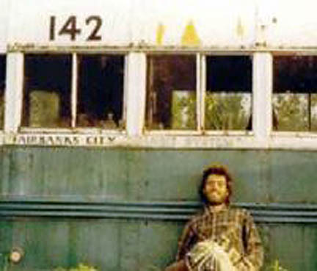

Transcendentalism

*Into the Wild*

By Jon Krakauer

Student Study Guide

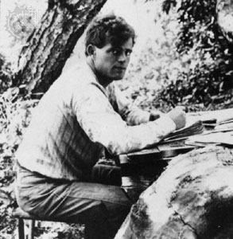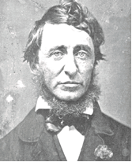

Notes on Thoreau and London:

Choose any 4 Journal Response Questions below.  Answer the questions in complete, well-written paragraphs (2-4 paragraphs for each).  Your answer can be personal and reflective.  I encourage you to be creative (but appropriate) in response to the answer.  Be sure to include specific details from the text to demonstrate that you have read the book.

Turn in the completed Journal for credit.  Due Date: ______MARCH 2______________________

Journal Response Questions

1. What do you think caused Chris to embark on his journey? (beginning of the novel)
2. What mistakes, if any, did Chris make before going to Alaska?
3. In a review of the book by Library Journal, one complaint about it was that Krakauer “never satisfactorily answers the question of whether McCandless was a noble, if misguided, idealist or a reckless narcissist who brought pain to his family.”  Which, in your opinion, was he?  Was he both?
4. McCandless was also greatly influenced by Henry David Thoreau. What did he borrow from Thoreau’s interaction with nature? How did he differ from Thoreau?
5. The author claims that Into the Wild is very much a story about a son’s relationship with his father. What conclusions did you make regarding McCandless’s response to his family? What did you learn about parental relationships from the narrative?
6. Do you feel that McCandless was either mentally ill or suicidal?  Use evidence from the text.
7. *What is Truth? Where did you get your sense of Truth?  What is McCandless’s sense of Truth?  How do you know?*
8. What significance, if any, do you attach to the note Chris left in the margins of *Dr. Zhivago*:  “Happiness only real when shared” as he neared the end of his life? (end of book, pg. 189)
9. Interview your parents/ guardian about something they always wished they would have done. Find out why they haven’t done it? What stopped them?
10. At the end of the reading, Krakauer asserts that one reason adults have so much difficulty understanding McCandless’s actions is that they struggle “to recall how forcefully [they] were once buffeted by the passions and longings of youth.” To understand this observation, one must be able to define what “the passions and longings of youth” are. What do these passions and longings have to do with escape? With the natural world? And if one can recall such passions and longings, how might this change the way one looks at McCandless’s death?

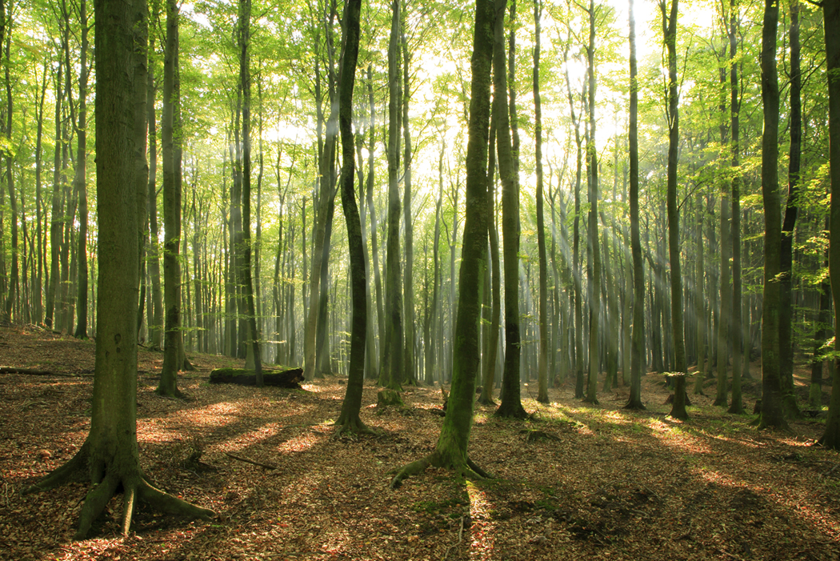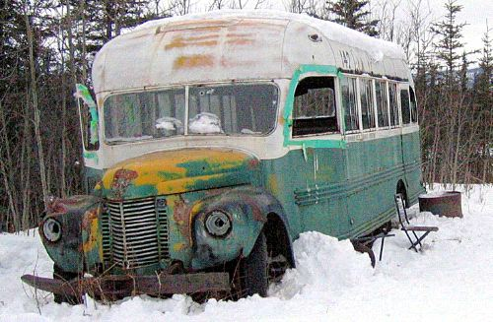

Novel Notes Pages 3-46

**Plot**

Jim Gallien – *Gentleman who drove Chris into Alaska to Stampede Trail. He tried to talk Chris out of odyssey, but Chris didn’t listen. Gallien described himself as having issues with people like Chris because they think that they can survive the dangers of the wild.*

Alexander/Alex –

April 28, 1992 –

Fairbanks City Transit System: bus 142 –

Thompson, Samel, and Swanson –

Wayne Westerberg –

Annandale, Virginia –

OXFAM –

Old yellow Datsun –

Connection made about Henry David Thoreau (Civil Disobedience) –

McDonalds -

Jan and Bob Burres-

Notes:

Novel Notes *continued…* Pages 47-97

**Plot:**

Ronald Franz –

The leather belt –

Relationship with his parents –

Gene Rosellini –

John Mallon Waterman –

Carl McCunn –

Davis Gulch –

Everett Ruess –

“NEMO 1934” –

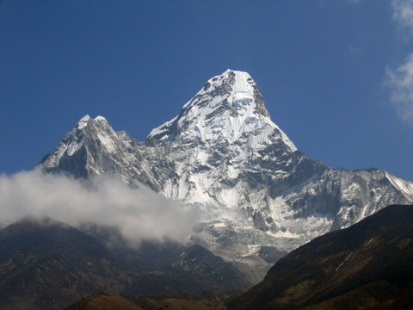

Notes:

*Novel Notes continued…* Pages 98-144

**Plot:**

Anchorage Daily News/*Time*/The Washington Post article on dead hiker –

Jim Gallien (reaction to article) -

Wayne Westerberg (reaction to article) -

Sam McCandless (reaction to article) –

Walt McCandless (characterize him) –

Marcia McCandless –

Billie (Wilhelmina) McCandless –

“Chris marches to a different drummer” (pg. 107) –

Loren Johnson –

Disappointment in sports (how does this connect?) –

“McCandless took life’s inequities to heart.” (pg. 113) –

Chris’s trip southwest after high school graduation –

Secret relationship with Marcia McCandless –

Carine McCandless (characterization) –

The Devil’s Thumb –

Importance of this story on story of McCandless –

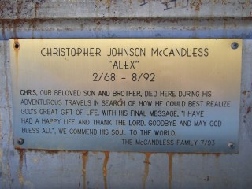

Notes

*Novel Notes continued…*Pages 145-203

**Plot:**

Lewis Krakauer –

Importance of this story on story of McCandless –

“I knew that people sometimes died climbing mountains. But at the age of twenty-three, personal mortality – the idea of my own death – was still largely outside my conceptual grasp.” (pg. 151). –

McCandless’s declaration of independence –

“Deliberate living” –

“He was right in saying that the only certain happiness in life is to live for others…” (pg. 169) –

The mistakes he made (Chapter 17 – End) –

Identification of moose –

Pot. Seed (potato seed) –

Characterization of Chris McCandless

Directions: Find evidence in the book for the following characterizations of Chris McCandless. Regardless of your own personal feelings, keep track of what evidence is provided for each of the following:

|  |  |  |
| --- | --- | --- |
|  | Examples | Quotes with pages for textual evidence |
| Arrogant/  Stupid  (“nuts”) |  |  |
| Courageous/  Wise (“beyond his years”) |  |  |
|  |  |  |
|  |  |  |

Into the Wild by Jon Krakauer

Section 2 Reading – Statement/Theme Support

Agree Disagree

Statement:

People are greatly affected by the relationships they have with their parents.

Page:

Explanation/Proof:

2.

Statement:

Our negative judgments (calling him “nuts”) of Chris McCandless are based on our stereotypes of what a sane person really is. Our American culture has decided what normal can be, and what normal cannot be.

Page:

Explanation/Proof:

3.

Statement:

Chris McCandless is a modern-day Messiah figure.

Page:

Explanation/Proof:

4.

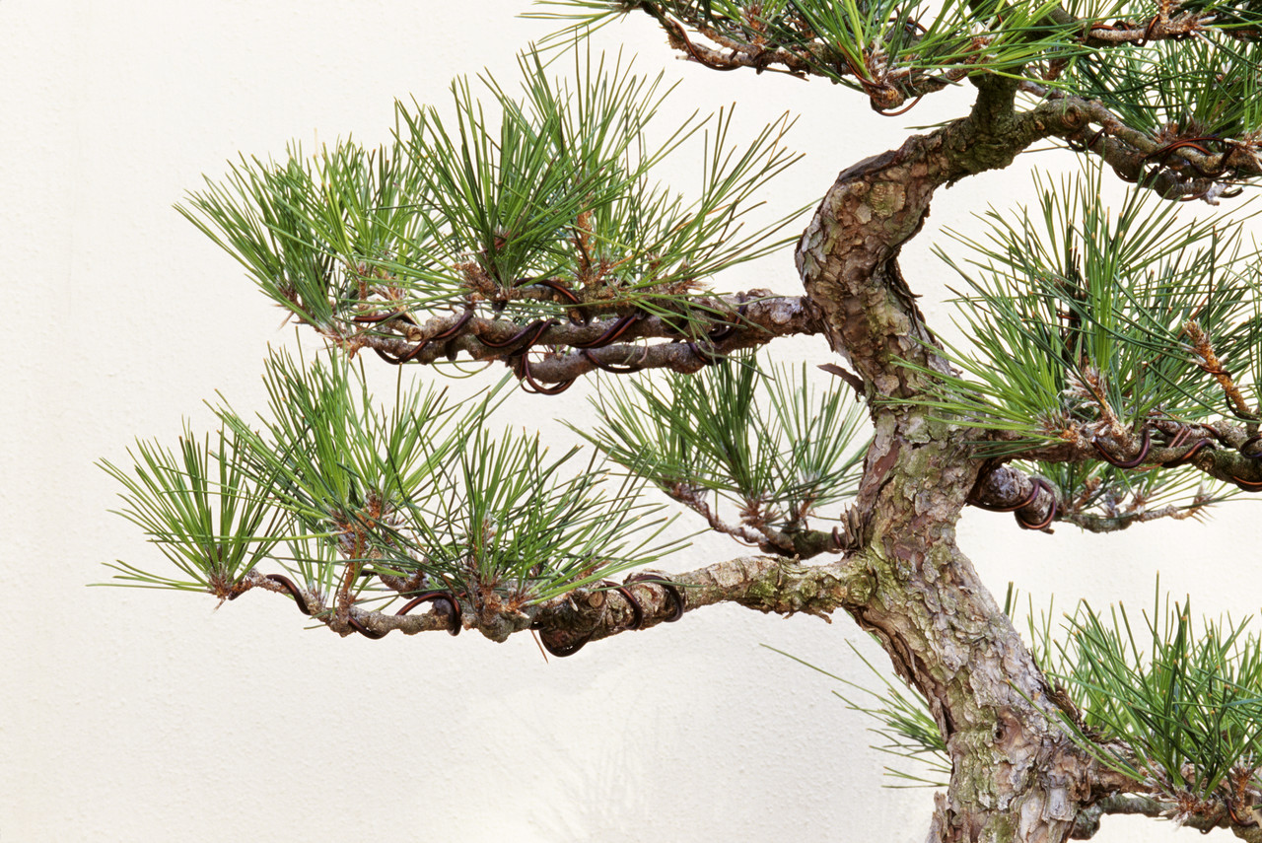

Statement:

There is an intrinsic need for companionship.

Page:

Explanation/Proof:

1.

*An Effective Comparison…*

* Describes the parts of the concept in detail before comparing
* Makes direct and clear comparisons with the concept, possibly emphasizing some of the contrasts.
* Draws conclusions about the two concepts in terms of their comparisons.
* Demonstrates an application of the information gained from the comparison and conclusions made.



*Harvey Silver’s 4 Phases of a Successful Comparison:*

Describe

Compare

Conclude

Apply

Conclusions Drawn

1. Are Chris and Walt more alike or different?
2. What has caused the similarities and differences between Chris and Walt?
3. How could Chris be so angry with his father?
4. How does this comparison enhance your understanding of Chris and his actions?

***How do they compare? What about their actions are similar?***

***Describe Chris’s actions over the course of the novel so far.***

Walt McCandless

Chris McCandless



***Describe Walt’s actions and behaviors.***

Application

Write a paragraph in which you will discuss the relationship Chris McCandless has with his dad. How are people affected by their backgrounds? How could the situation between Chris and his dad have been different? How important is the family relationship on any individual?

Section 3 Reading

Into the Wild – Krakauer

Conclusions Drawn

1. Are Chris and Thoreau more alike or different? Why?
2. How does this comparison enhance your understanding of Chris and his actions?

***Describe Thoreau’s actions.***

Application

Write a paragraph in which you will discuss the similarities and differences of Chris and Thoreau. How might a reader better understand Chris through the actions of Thoreau?

***How do they compare? What about their actions are similar?***

***Describe Chris’s actions over the course of the novel so far.***

Thoreau

Chris McCandless

Eddie Vedder “Society”

Into The Wild OST

INTRO: Bm

D A D

Oh, it's a mystery to me

D G A

We have a greed with which we have agreed

G A Bm

And you think you have to want more than you need

G A Bm

Until you have it all you won't be free

G D

Society, you're a crazy breed

A Bm

Hope you're not lonely without me...

D A D

When you want more than you have you think you need...

D G A

And when you think more than you want your thoughts begin to bleed

G A Bm

I think I need to find a bigger place

G A Bm

Because when you have more than you think you need more space

G D

Society, you're a crazy breed

A Bm

Hope you're not lonely without me...

G D

Society, crazy indeed

A Bm

Hope you're not lonely without me...

SOLO: D - A - D / D - G - A / G - A - Bm (x2) / G - D - A - Bm

D A D

There's those thinking, more-or-less, less is more

D G A

But if less is more, how you keeping score?

G A Bm

Means for every point you make, your level drops

G A Bm

Kinda like you're starting from the top, you can't do that...

G D

Society, you're a crazy breed

A Bm

Hope you're not lonely without me...

G D

Society, crazy indeed

A Bm

Hope you're not lonely without me...

G D

Society, have mercy on me

A Bm

Hope you're not angry if I disagree...

G D

Society, crazy indeed

A Bm

Hope you're not lonely...without me...

UNIT QUIZ/TEST STUDY GUIDE

Section #1 (pg. 3-46)

Quizzes/Test: Below is a list of topics from each section of reading. You are free to take notes on the following topics as you read. You should take notes on the topics concerning:

* Who or what the topic is
* What he/she has to say and/or what was said about the place/object/person/event/quote/etc.
* How it relates to the story/McCandless (Draw connections to novel) – Be specific to the section that you are reading from.
* Possibly how this place/object/person/event/quote/etc. gives clues to the mystery of McCandless

Realize that I will be quizzing you on some of these topics along the way, as well as using these topics to test you at the end of the Unit. I may not choose to use all of these topics in quizzing/testing you, so be sure to be prepared. The more specific you are, the better. If you are too general and missing the connections this place/object/person/event/quote/etc has to the novel, you will lose points.

Jim Gallien – *Gentleman who drove Chris into Alaska to Stampede Trail. He tried to talk Chris out of odyssey, but Chris didn’t listen. Gallien described himself as having issues with people like Chris because they think that they can survive the dangers of the wild.*

Alexander/Alex –

April 28, 1992 –

Fairbanks City Transit System: bus 142 –

Thompson, Samel, and Swanson –

Wayne Westerberg –

Annadale, Virgina –

OXFAM –

Old yellow Datsun –

Connection made about Henry David Thoreau (Civil Disobedience) –

McDonalds -

Jan and Bob Burres –

Section #2 (pg. 47-97)

Ronald Franz –

The leather belt –

Relationship with his parents –

Gene Rosellini –

John Mallon Waterman –

Carl McCunn –

Davis Gulch –

Everett Ruess –

“NEMO 1934” –

Section #3 (pg. 98 – 144)

Anchorage Daily News/*Time*/The Washington Post article on dead hiker –

Jim Gallien (reaction to article) -

Wayne Westerberg (reaction to article) -

Sam McCandless (reaction to article) –

Walt McCandless (characterize him) –

Marcia McCandless –

Billie (Wilhelmina) McCandless –

“Chris marches to a different drummer” (pg. 107) –

Loren Johnson –

Disappointment in sports (how does this connect?) –

“McCandless took life’s inequities to heart.” (pg. 113) –

Chris’s trip southwest after high school graduation –

Secret relationship with Marcia McCandless –

Carine McCandless (characterization) –

The Devil’s Thumb –

Importance of this story on story of McCandless –

Section #4 (pgs. 145-203)

Lewis Krakauer –

Importance of this story on story of McCandless –

“I knew that people sometimes died climbing mountains. But at the age of twenty-three, personal mortality – the idea of my own death – was still largely outside my conceptual grasp.” (pg. 151). –

McCandless’s declaration of independence –

“Deliberate living” –

“He was right in saying that the only certain happiness in life is to live for others…” (pg. 169) –

The mistakes he made (Chapter 17 – End) –

Identification of moose –

Pot. Seed (potato seed) –

Additional concepts that will show up on the Unit Test:

Jack London

Law of Club and Fang

Naturalism (naturalist)

Darwin

Romanticism (Romantic)

Henry David Thoreau

“simple living”

“Live deep…”

Civil Disobedience

Literary Hero

Themes from novel

Siddhartha

Krakauer’s- Characterization